*Odyssey Compilation/Installation Instructions:*

**Option 1** (Fastest method – Recommended): Download Singularity Container from Github

*Note:* Singularity must be installed on the system for this option to work. Installing Singularity on the system requires root access, but using it does not require root access. In this way you may either install singularity (if you are a local Admin) if it doesn’t exist, or request for it to be installed (if you are not a local Admin – e.g. on a High Performance Cluster).

*If Singularity is installed on the system:*

1. Download Odyssey via git to your working directory folder
   1. *Note*: The Odyssey git contains all the necessary folders, scripts, and importantly, the Odyssey Dependency container (OdysseyDependencies.sif). The container is a self-enclosed environment that has all of Odyssey’s dependency programs packaged inside. Using Singularity, we can call into the container and run the necessary programs without having to install anything on the host system.

cd /Directory/You/Want/To/Work/From

git clone git@github.com:Orion1618/Odyssey.git

1. You’re done. Start using Odyssey

*If Singularity is NOT installed on the system BUT you are a local ADMIN (for PC and MacOS users follow* ***Option 2*** *Steps 1-3 prior to performing the following steps):*

1. Download Odyssey via git to your working directory folder
   1. *Note*: The Odyssey git contains all the necessary folders, scripts, and importantly, the Odyssey Dependency container (.sif). The container is a self-enclosed environment that has all of Odyssey’s dependency programs packaged inside. Using Singularity we can call into the container and run the necessary program

cd /Directory/You/Want/To/Work/From

git fetch remotenameURL

1. Install Singularity (requires root/admin access)
   1. Download singularity (version 2.5.2 NOT version 3.x.x) to the downloads folder from: <https://singularity.lbl.gov/release-2-5-2>
   2. Move the download from the Linux download folder to your home directory

mv ~/Downloads/singularity-2.5.2.tar.gz ~/singularity-2.5.2.tar.gz

* 1. Unzip the zipped file

tar -xzf singularity-2.5.2.tar.gz

* 1. Change into the Singularity directory

cd singularity-2.5.2.tar.gz

* 1. Install a couple of Linux dependencies:

apt -y install make gcc python libarchive-dev

* 1. Configure Singularity

./configure --prefix**=**/usr/local

make

sudo make install

1. You’re done. Start using Odyssey

If Singularity is NOT installed on the system AND you are NOT a local ADMIN:

1. Either request your system admin to install Singularity for you OR
2. Install/configure Odyssey dependencies locally using **Option 3**

**Option 2** (Use this method if you want the most up-to-date Odyssey dependencies): Compile Singularity Container from recipe/definition file

Note 1: Singularity must be installed on the system and this requires ROOT access. If you do not have Admin rights to your computer THIS OPTION WILL NOT WORK

Note 2: If you are installing Singularity on MacOS or on PC follow the below instructions. If you are installing Singularity to a Linux distribution skip to step # 4

1. Install Oracle Virtual Box (for PC and MacOS hosts only) : <https://www.virtualbox.org/>
   1. 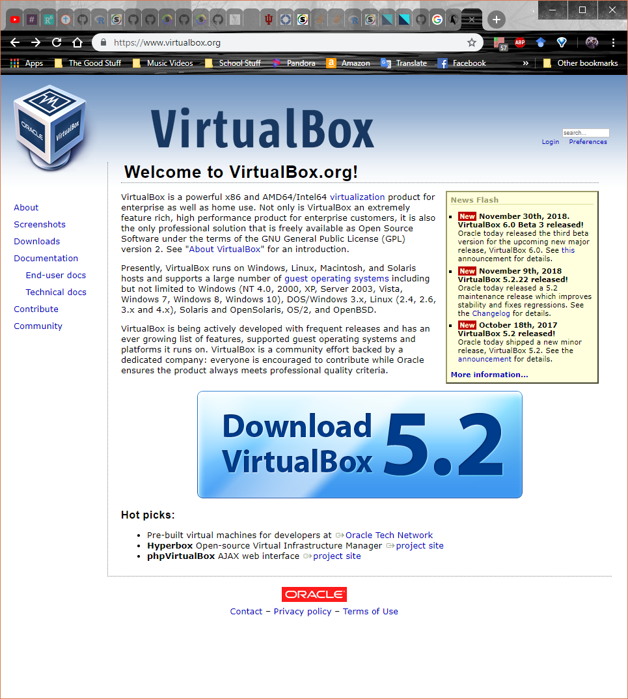
   2. 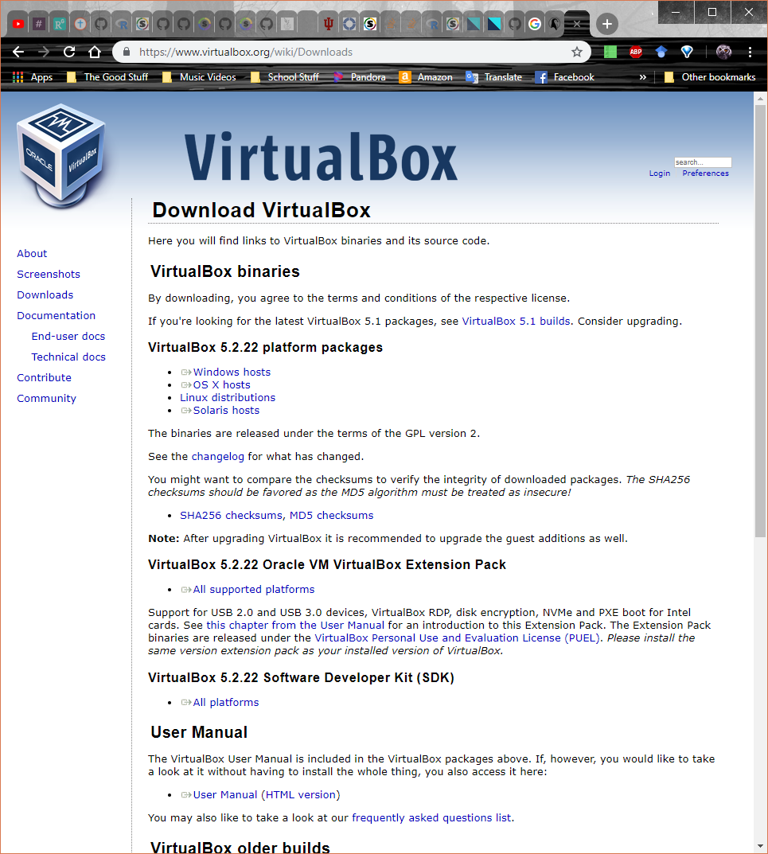
2. Setup a Linux Installation on the Virtual Box Virtual Machine (VM)
   1. Download Ubuntu’s latest LTS ISO image
   2. 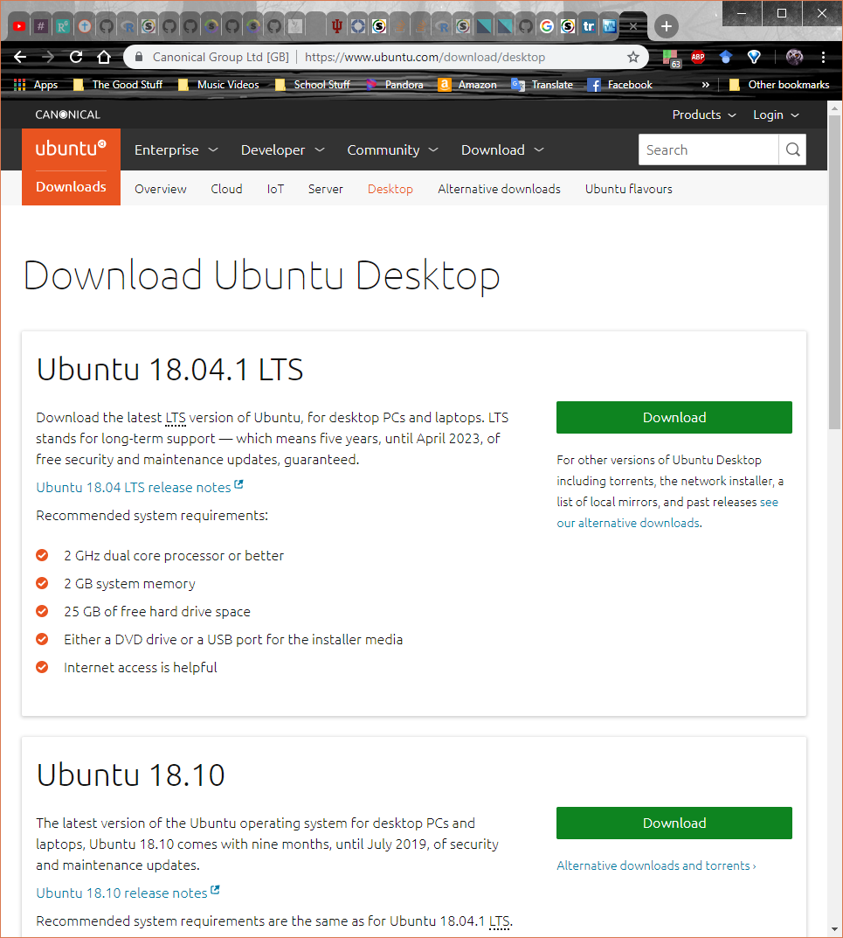
   3. After launching Virtual Box Create a New Virtual Machine
   4. 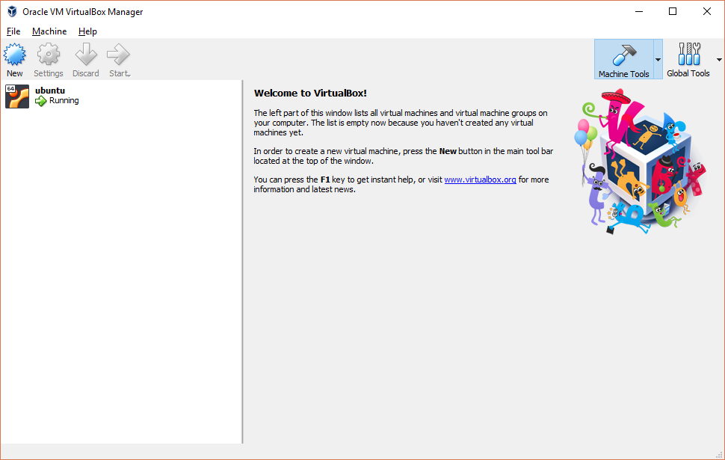
   5. Name it Ubuntu (the “Type” and “Version” will then be set automatically) and select Next

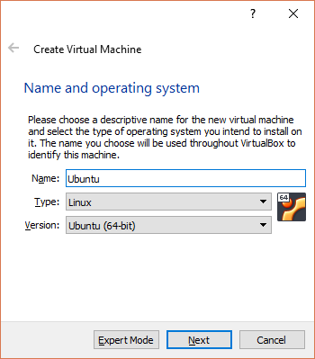

* 1. Set the memory to at the boundary between the green and red line (which changes depending on your system) and select Next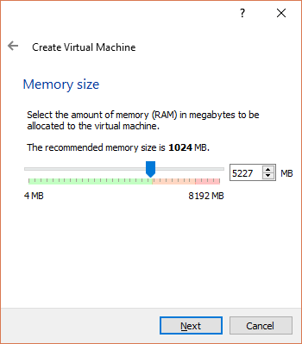
  2. Select Create a virtual hard disk now and select Create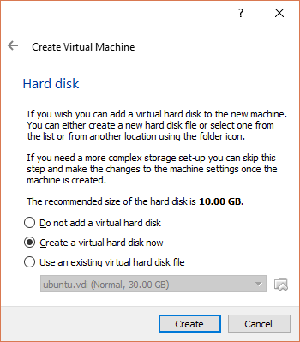
  3. Select VDI and select next
  4. 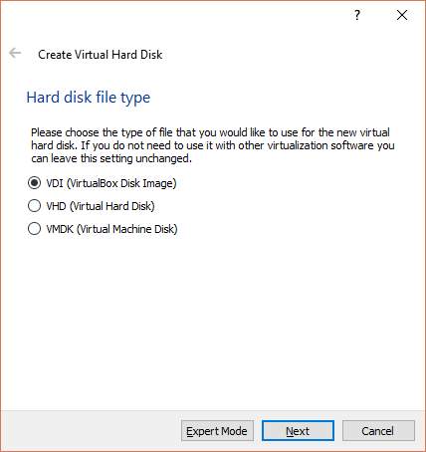
  5. Select Fixed size and click next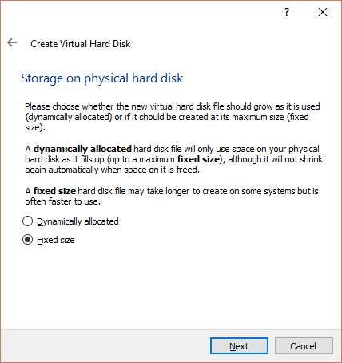
  6. Select at least 25GB of storage space and hit Create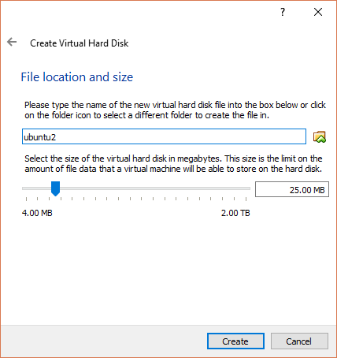
  7. Select the Ubuntu VM (which highlights it blue) and choose Settings

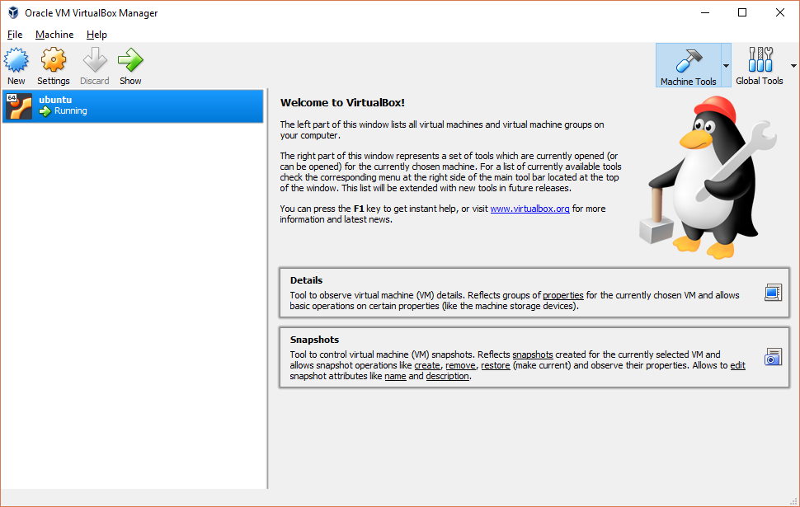

* 1. Navigate to Storage and click the Add optical drive button. In the dialog box click on the Ubuntu ISO that you downloaded earlier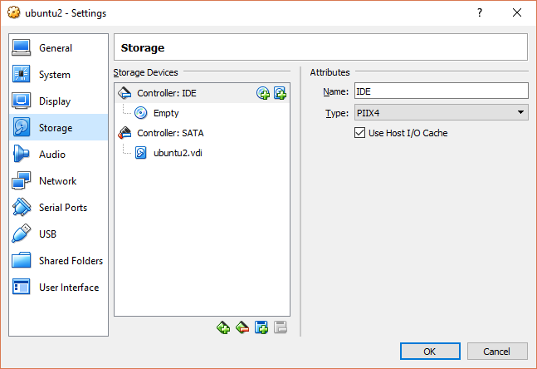
  2. Then Navigate to Shared Folders

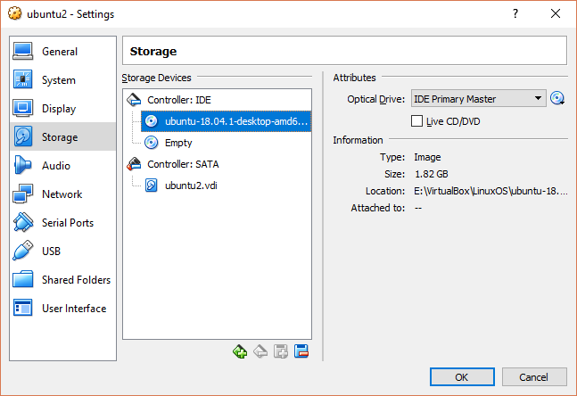

* 1. Under Folder Path click browse and select an empty folder that you have created. This will allow you to extract the Odyssey Container from your VM. Also select “Auto-mount” and “Make Permanent”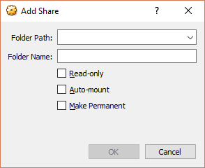

1. Running the Ubuntu Virtual Box
   1. Select the VM in Oracle and click the Start arrow to start the VM
   2. 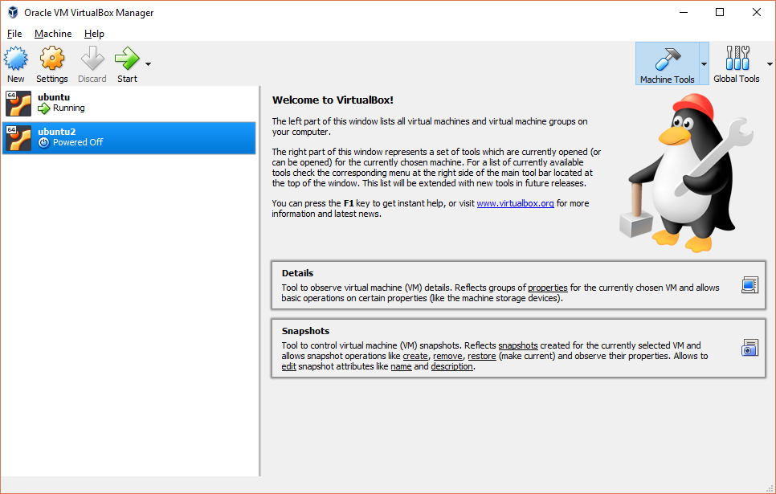
   3. On startup select Install Ubuntu and go through the setup options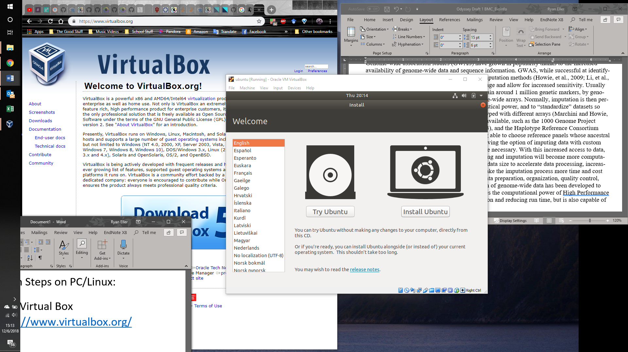
   4. Select “Minimal Installation” and “Download Updates while installing Ubuntu”0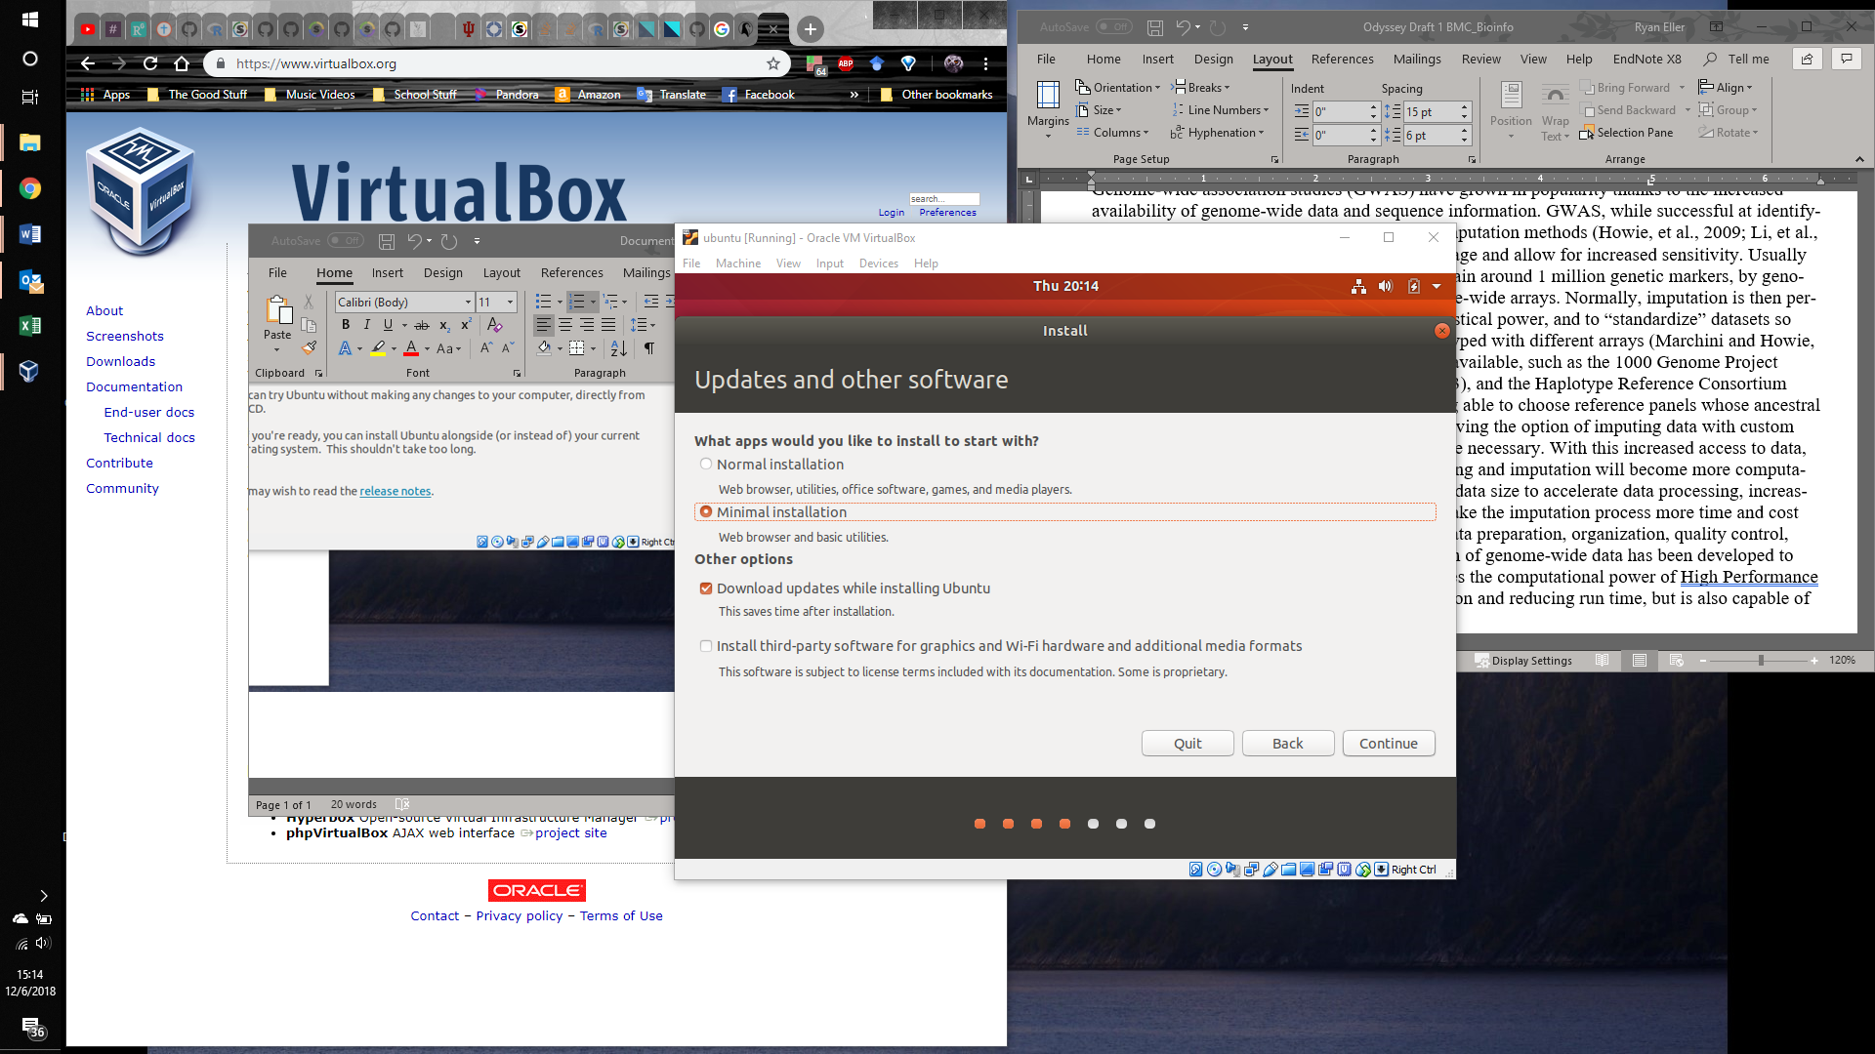
   5. Allow changes to disk to be made.

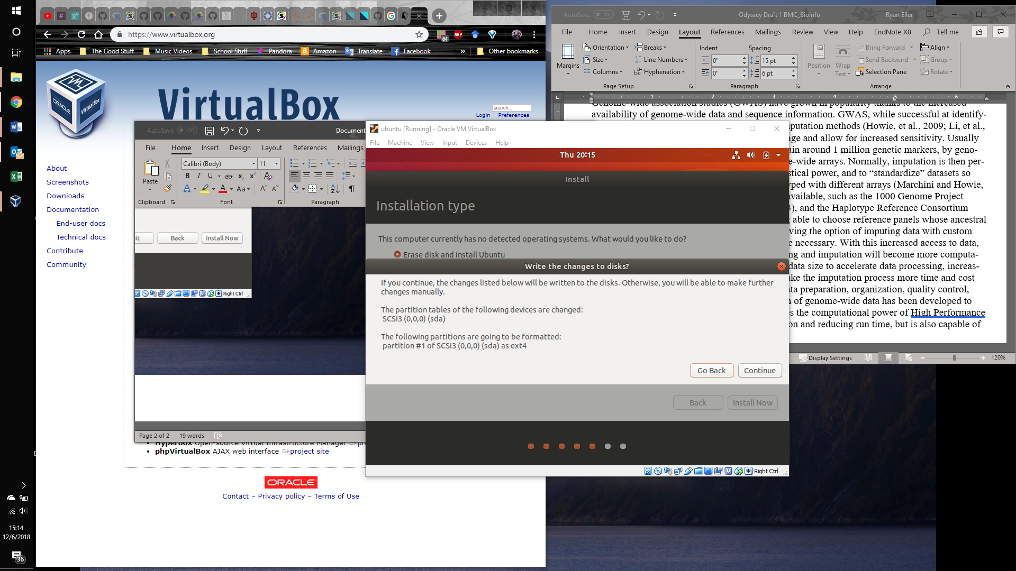

* 1. Select “Erase disk and install Ubuntu” (this will not wipe the entire disk you allotted to the VM; only it’s allocation that you setup in a previous step).

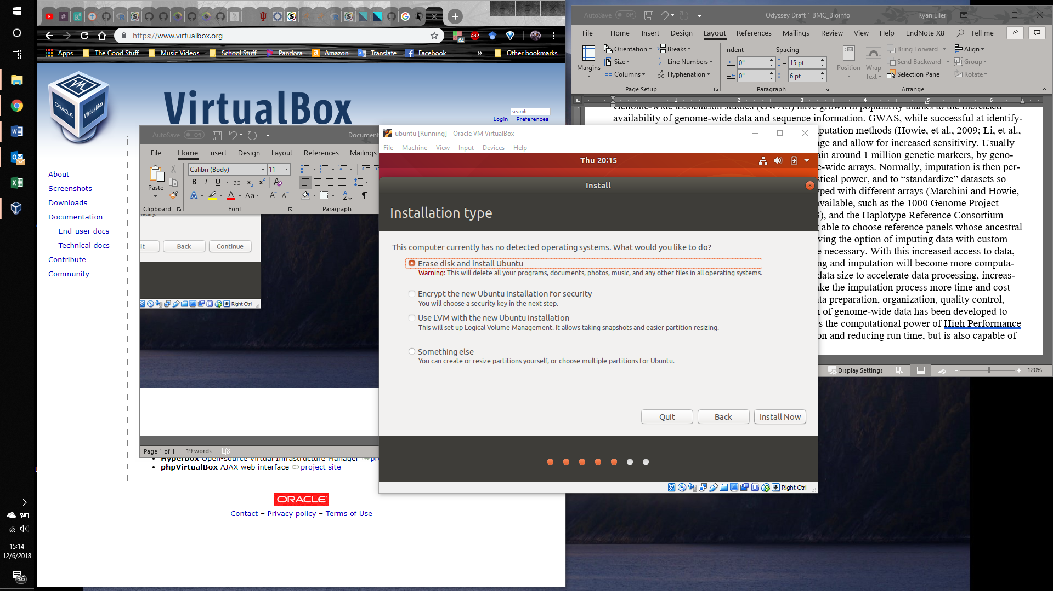

* 1. Go through the rest of the setup and follow the on-screen instructions

1. Install Singularity (requires root/admin access) to build Odyssey Container
   1. Download singularity (version 2.5.2 NOT version 3.x.x) to the downloads folder from: <https://singularity.lbl.gov/release-2-5-2>
   2. Move the download from the Linux download folder to your home directory

mv ~/Downloads/singularity-2.5.2.tar.gz ~/singularity-2.5.2.tar.gz

* 1. Unzip the zipped file

tar -xzf singularity-2.5.2.tar.gz

* 1. Change into the Singularity directory

cd singularity-2.5.2.tar.gz

* 1. Install a couple of Linux dependencies:

apt -y install make gcc python libarchive-dev

* 1. Configure Singularity

./configure --prefix**=**/usr/local

make

sudo make install

1. Run the following command with the Odyssey Definition/Recipe File (located in your home directory -- ~/home/) to make a completely up-to-date Odyssey container

sudo singularity Odyssey.sif OdysseyF.def

1. The resulting Odyssey.sif container image should then be put in the shared folder you set up previously located in /media/[name_of_shared_folder]/

mv Odyssey.sif /media/[name_of_shared_folder]/Odyssey.sif

1. The .sif file should now be in the folder for you to transfer to a different computer for use (or you could use the container on the existing VM given you gave it enough storage space to accommodate Odyssey’s likely (depending on your samples) heavy storage requirements.

**Option 3** (Slow method that doesn’t utilize Singularity – Not Recommended as it requires manual compilation of dependencies which can be problematic): Manually install Odyssey dependencies

1. As this step is very long and tedious, I will often refer back to the dependency program’s website since are better able to describe the installation of their program than I can. A major hurdle with this method is getting all the library dependencies installed so packages install. While these instructions are far from a fool-proof method of getting everything installed, I will list the recommended order that the programs should be installed as well as several helpful tips. It is recommended that you install these programs to a common folder for easier of configuring Odyssey’s configuration file.
2. Install htslib (the dependency for BCFTools)
   1. The link is found here along with its instructions. Non-ADMIN users will likely need to make heavy use of the “--prefix” configure tag since the default of installing to /usr/local/ will likely be blocked.
      1. <http://www.htslib.org/downloa>
3. Install BCFTools
   1. Similar to the installation for htslib
4. Install Plink1.9
   1. <https://www.cog-genomics.org/plink2>
5. Install Plink 2.0 (alpha)
   1. <https://www.cog-genomics.org/plink/2.0/>
6. Install Shapeit2
   1. [http://mathgen.stats.ox.ac.uk/genetics_software/shapeit/shapeit.html#download](http://mathgen.stats.ox.ac.uk/genetics_software/shapeit/shapeit.html" \l "download)
7. Install Impute4 (requires contacting the author Dr. Marchini for permission)
   1. <https://jmarchini.org/impute-4/>
8. Download R
   1. <https://www.r-project.org/>
9. Download R packages
   1. Install.packages(‘tidyverse’, dependencies=T)
   2. Install.packages(‘manhattanly’, dependencies=T)
   3. Install.packages(‘qqman’, dependencies=T)
   4. Install.packages(‘data.table’, dependencies=T)

**Troubleshooting Guide:**

There is a chance if you are a non-root user that some libraries may not be available for the packages to compile correctly (i.e. gcc may not be installed). In these cases it is often best to refer to the program error messages and attempt to install the necessary dependency all the while specifying a target directory in which the user has full access.